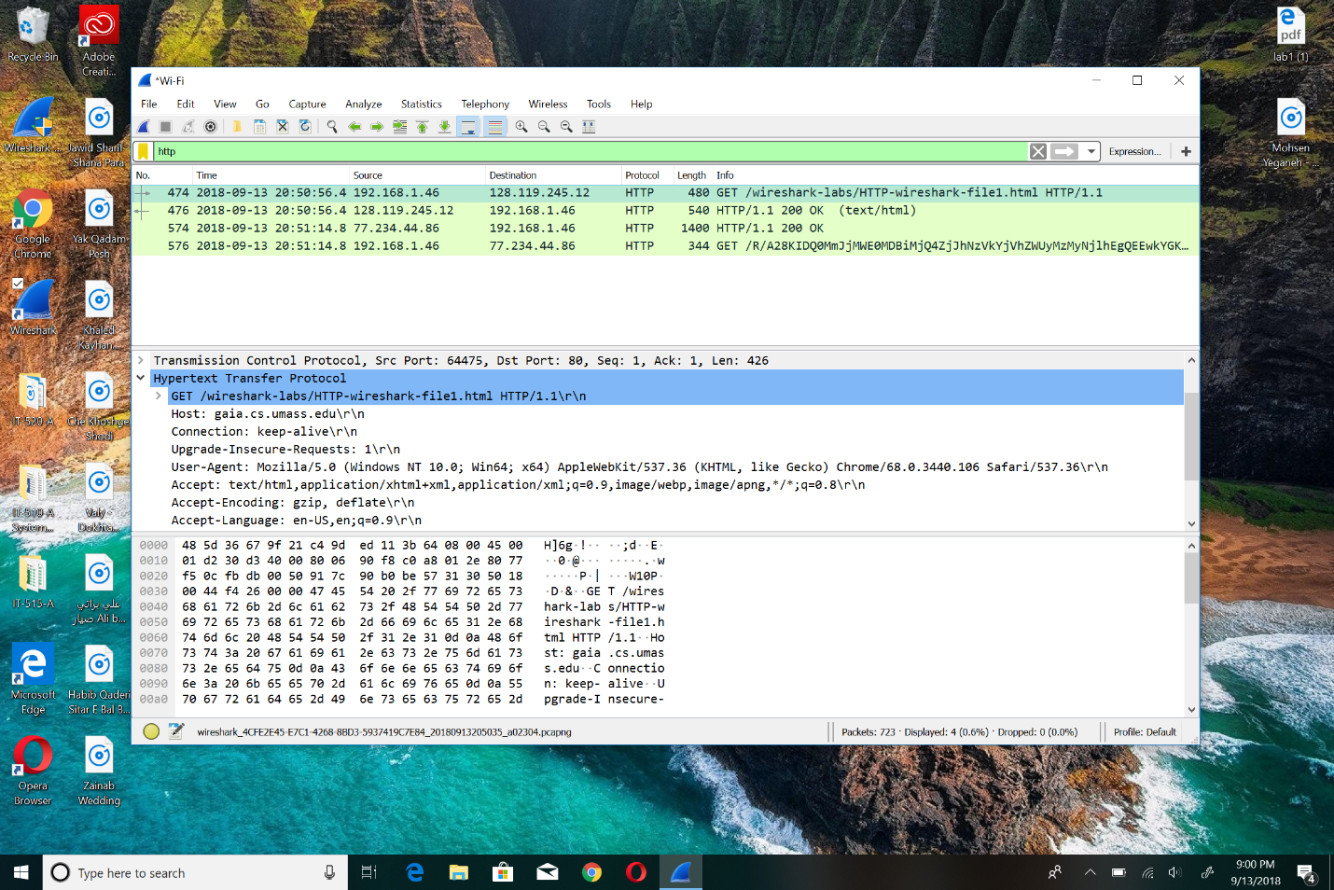3: My IP address is 192.168.1.46 and the <http://gaia.cs.umass.edu/wireshark> is 128.119.245.12